**Initial Release Schedule of The Products Backlog Items**

|  |  |  |  |  |
| --- | --- | --- | --- | --- |
| **No.** | **Item** | **Dependencies** | **Business Value (1 least – 10 most)** | **Release Schedule**  **(Sprint 1 | 2 | 3 | …)** |
| F1 | Add a new member |  | 7 | Sprint 1 |
| F2 | Add a sales record | F1 | 8 | Sprint 1 |
| F3 | Edit a sales record | F2 | 8 | Sprint 1 |
| F4 | Analyse a member's grocery needs | Existence of a member's record and that member's sales records | 9 | Sprint 2 |
| F5 | *Add product* | … | 8 | Sprint 1 |
| F6 | *Edit product* | F5 | 8 | Sprint 2 |
| F7 | *Add order* | … | 8 | Sprint 2 |
| F8 | *Edit order* | F7 | 8 | Sprint 2 |
| F9 | Export data | … | 9 | Sprint 2 |
| F10 | … | … | … | … |
| … |  |  |  |  |

**Task 1**

1. **Add sales record**
2. Business value

In this task it has a higher business value because it is important that we have a place to store all data that is needed from customer and what they have bought in the store to know if the company is making money or not.

1. Development Effort

In this task this should take a decent amount of time to finish because we want to make sure that data can pass into the database.

1. Feature Dependency

This task is dependent on other features like members. Because sales record needs to know who bought it and what item they bought.

1. Date Needed / Timeline

This task will be completed in sprint 1 with an estimated time of 12 hours

1. **Edit sales record**
2. Business value

The business value in this task is also important because employee may make some human error that they entered the wrong information. So, this will allow them to make some adjustment inside the database.

1. Development Effort

This task should not take much of our time to build but we also want to make sure that the feature working fine.

1. Feature Dependency

This feature is dependent on data inside the database that allow employee edit all faulty data.

1. Date Needed / Timeline

In this task we must finish the database and add sales record. Then we can proceed to finish this task within sprint 1 with an estimated time of 12 hours.

1. **Add Product**
2. Business Value

In this task, it is has a very high business value as it is very important that the customer is able to browse every single product that is currently being sold by the company

1. Development Effort

In this task, it should not take a decent amount of time as we want to make sure all the most important characteristics of the product is recorded into the database.

1. Feature Dependency

This task should not be dependant on any features as it is essentially recording the characteristics of any product to be sold by the company.

1. Date needed / Timeline

This task is to be completed in sprint 1 with an estimated time of 12 hours.

1. **Add new member**
2. Business Value

In this task, it is one of the highest business values as most of the features in the software is dependant on what the members like to buy and it helps the company understand the general behaviour and preferences of their customers.

1. Development Effort

This task should take a decent amount of time but we have to make sure that all the members’ details that are important for the company such as their preferences is properly recorded into the database and can be used for future processing.

1. Feature Dependency

This task should not be dependant on other features as each new member that registers with the company should be added without causing any problems.

1. Date needed / Timeline

This task is to be completed in sprint 1 with an estimated time of 13 - 14 hours.

**Task 2**

1. **Add sales record**

This task will be important than others because of the main purpose of this project is to provide an organized collection of data to be stored inside the database for the company to make their next decision for their customer needs.

1. **Edit sales record**

Editing data inside the database should also be important because some of the backlog item dependent on more accurate data to function. However, to make this work we must first implement the database.

1. Add Product

This task is also important because this will allow the company to know how many products to restock. And allow them to add new products to the company to let the customer try out new things.

1. Add new member

This task will be the highest weighting in the project without members the company will not be able to keep tracks on what is their regular customer need the most on the daily basis.

**Task 3**

the highest priority item from the Product backlog that could be developed in one sprint

1. “Add new member” is our highest priority that will be developed within sprint 1

**Task 4**

**WBS( Work- breakdown Structure)**

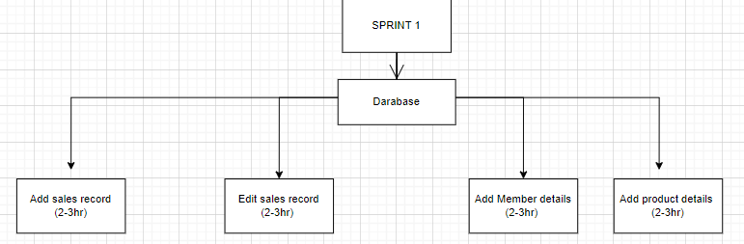

**Tutor**

Miss Robina Tinawin

**Team Members**

* Vignesh (Leader)
* Ngau Yong Sheng
* Chiam Jun Hao
* Derrick liew
* Yit Kim Leong

**Comments**

-Group

Our group has reached a decision and agreed on the backlog items to be prioritised. It seems appropriate, and the backlog item's importance is relatively high. It should also be noted that it is a stand-alone feature, as it does not rely on other features.

Vighnesh A/L Ganapathi

I agree with our decision for the backlog since this items will be helpful for the features of the system.

-Ngau Yong Sheng

I agree with the items in the backlog, as they seem to be very logical and simple as well as important.

-Chiam Jun Hao

I agree to the statement above that my team came up with because storing data in the database is much more important than other features.

-Derrick

I have agree with the team decision that my team decide to choose the backlog items, because it seem very simple and important.

-Yit Kim Leong

I agree with the decision of the team and it is clear to me that most of the backlog items importance is clearly defined and which part we should focus on is shown.